**MONITORING ODG,IBANk all, DB_COMPARE ,** **Kapasitas HDD DB**

**Laporan After SOD 20231004**

**ODG DC**

**ODG DC2**

**ODG DRC**

**Data Record DB COMPARE REPORT DC vs DC2**

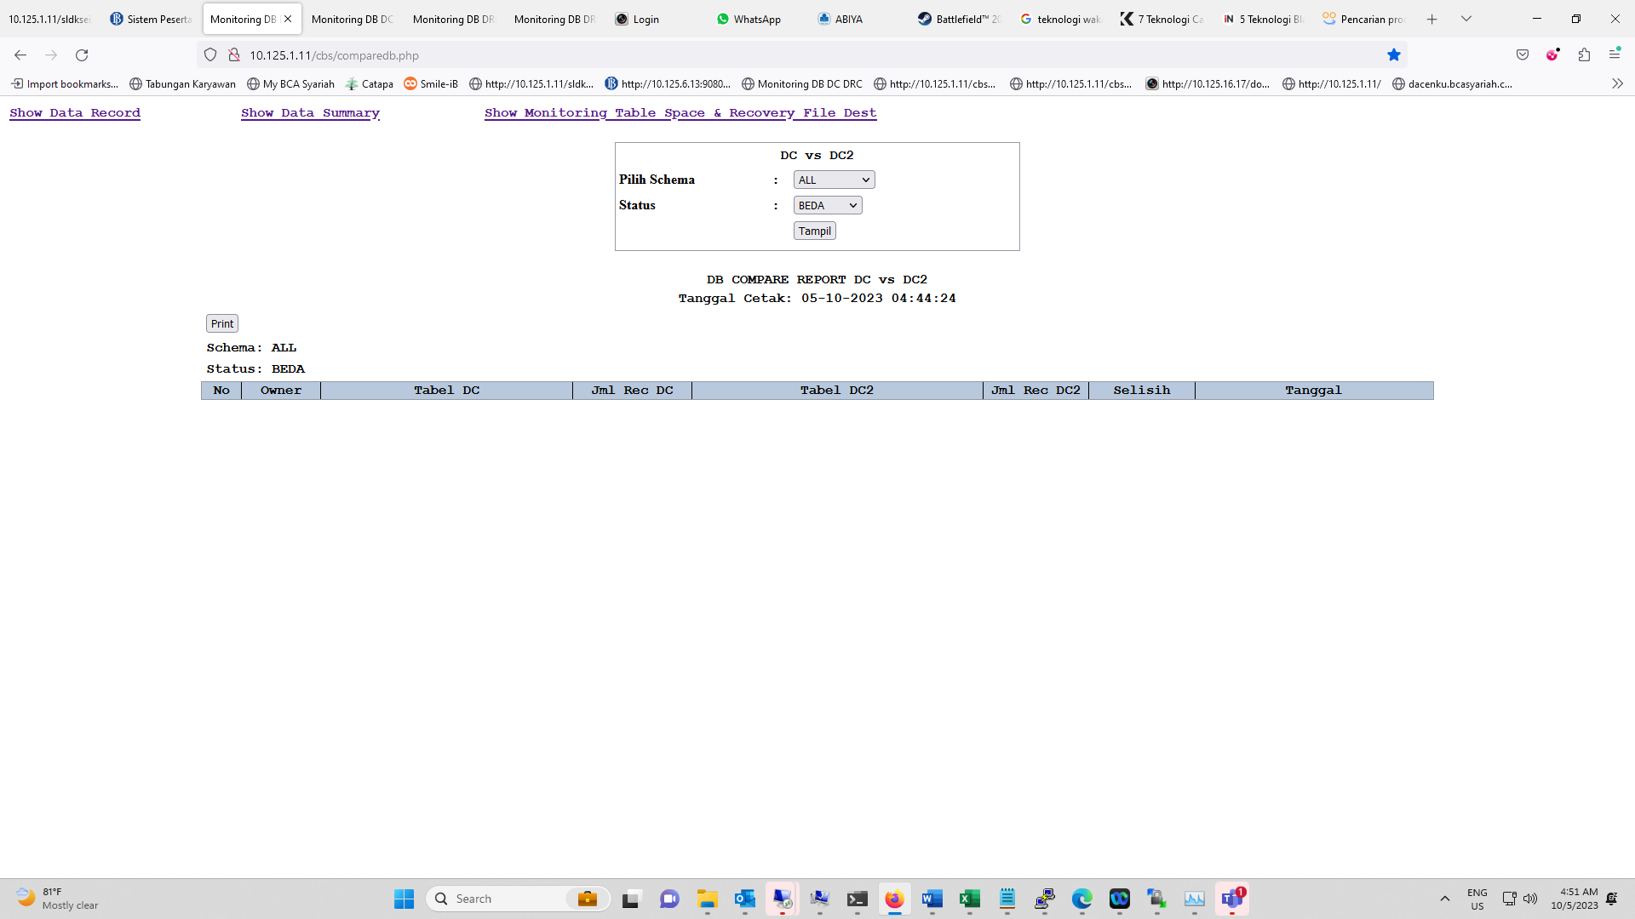

**Data Record DB COMPARE REPORT DRC vs DC (terdapat selisih setelah proses EOM namun sekarang sudah kembali Normal)**

**Data Summary DB COMPARE REPORT DC vs DC2**

**Data Summary DB COMPARE REPORT DRC vs DC**

DB_Compare Report After SOD

C_CABANG

181|||2023-10-04 21:54:28.550879000|Server-DC

|181||2023-10-04 21:54:30.434696000|Server-DR

C_DEPOSITO

67058|6399484237554.19|||||2023-10-04 21:53:33.374123000|Server-DC

||67058|6399484237554.19|||2023-10-04 21:53:45.675737000|Server-DR

C_GL

39072997604960.07435582277650488|||2023-10-04 21:54:09.371036000|Server-DC

|39072997604960.07435582277650488||2023-10-04 21:54:11.143041000|Server-DR

C_TABUNGAN

617875|1975382636716.452676776328887|||||2023-10-04 21:53:17.859177000|Server-DC

||617874|1975382636716.452676776328887|||2023-10-04 21:53:25.380562000|Server-DR

C_USER

3491|||2023-10-04 21:54:30.779523000|Server-DC

|3491||2023-10-04 21:54:33.228582000|Server-DR

C_CIF

573268|||2023-10-04 21:54:26.673390000|Server-DC

|573267||2023-10-04 21:54:28.146582000|Server-DR

C_GIRO

4591|1694101960930.61184307690932|||||2023-10-04 21:53:52.943666000|Server-DC

||4591|1694101960930.61184307690932|||2023-10-04 21:54:01.920377000|Server-DR

C_HISTTRANSAKSI

104519957|||2023-10-04 21:54:13.469002000|Server-DC

|104519957||2023-10-04 21:54:21.442963000|Server-DR

C_TRANSAKSI

80081|||2023-10-04 21:54:11.570944000|Server-DC

|79810||2023-10-04 21:54:12.991576000|Server-DR